**Task 2: User Management and Access Control**

**Objective**

To securely configure user access and directories for Sarah and Mike, and enforce password policies.

**Step 1: Create User Accounts with Secure Passwords**

# Create user

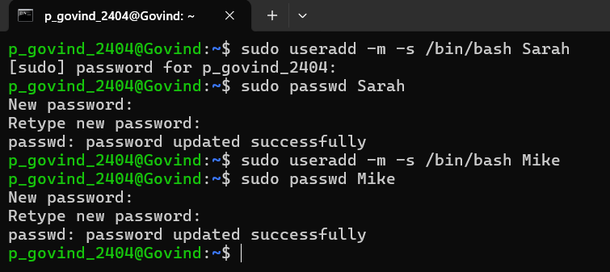

#Verification:

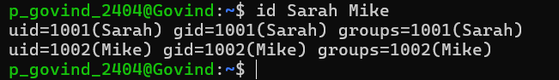

**Step 2: Create Isolated Workspace Directories**

# Create workspaces

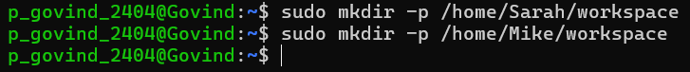

# Set ownership



# Restrict access to owner only



Verification:

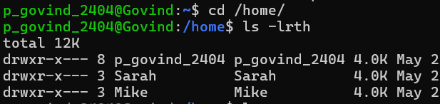

**Step 3: Enforce Password Expiration Policy (Every 30 Days)**

# Commands



Verification:

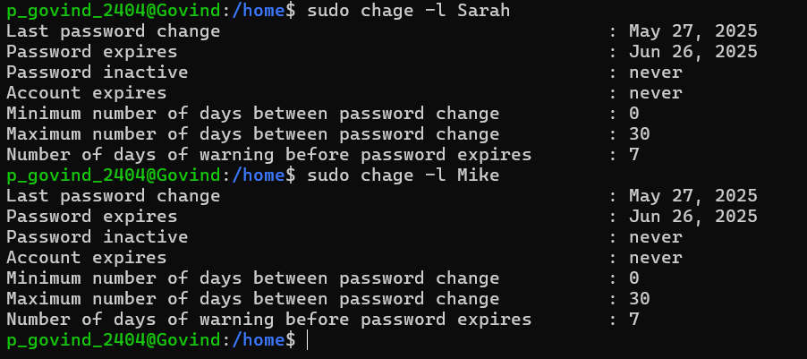

**Step 4: Enforce Password Complexity Requirements**

1.Install PAM password quality module (if not already installed):

sudo apt install libpam-pwquality -y

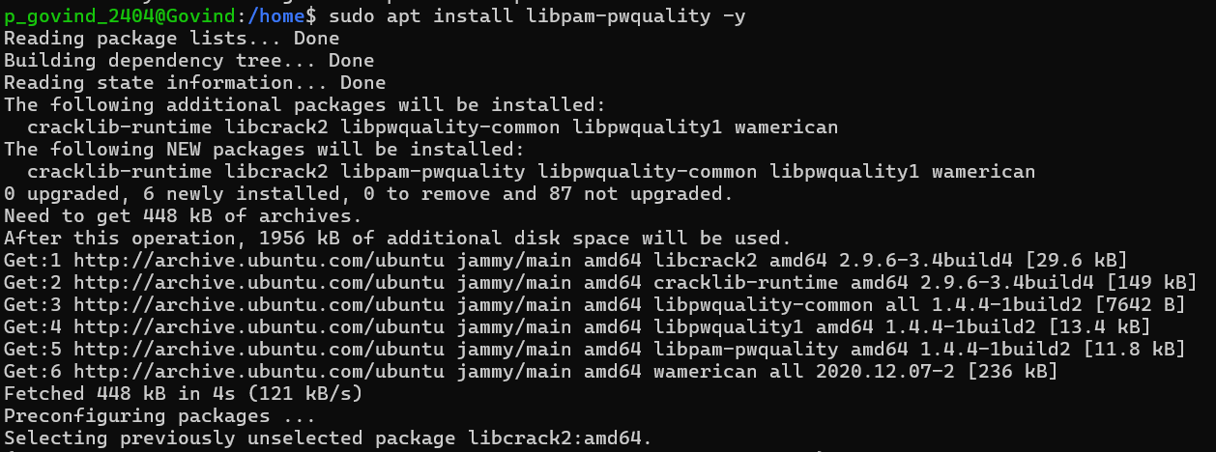

2. Edit PAM config: sudo nano /etc/pam.d/common-password

Find this line:

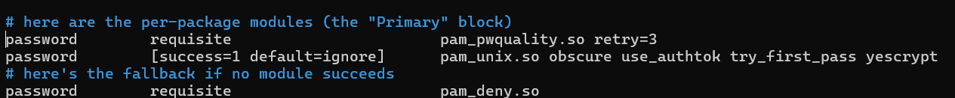

Update it to:



* This enforces:
  + At least 1 uppercase (ucredit=-1)
  + At least 1 lowercase (lcredit=-1)
  + At least 1 digit (dcredit=-1)
  + At least 1 special character (ocredit=-1)
  + Minimum 8 characters

1. Save and exit (Ctrl+O, Enter, Ctrl+X)